

***HUMAN COMMUNITY SERVICES INC.***

***CORN /MAIS PROJECT IN HAITI***

***WWW.HCSINC2002.ORG***

***Tel: +786 285 7109*** [***/HUMANC2003@YAHOO.COM***](mailto:/HUMANC2003@YAHOO.COM)

***Email: humanc2003@hcsinc2002.org***

HUMAN COMMUNITY SERVICES, INC is a non-profit (501c3) organization established in the South Florida area since 2002, with the primary objective of providing support to the needy, in several geographic areas of the Caribbean, South America, Africa and the United States, in as many domains as our sensibilities are called upon: food procurement, health care support services, education, job assistance among other services.

Our aim is to enlarge our reach and become involved in insuring the building and availability of infrastructures for the delivery of those services through multi-faceted projects, such as schools, hospitals, training facilities, technology hubs, water treatment facilities, food production farms and plants and the like.

Our Mission

At Human Community Services, Inc. (HCS) we truly wish that we could say that being engaged in productive services to improve the conditions of humanity throughout the entire world was our vision. But it is not. Perhaps someday it will be. Only God knows!!! This is truly our most fervent desire.

But in the current stage of the evolution of our young organization, our most pressing mission is to help the greater number of those in need. That is why, presently, our concentration is in the areas of the Caribbean, South America, Africa and the United States. Our mission generally is to create an environment where we can

Hoist the human spirit out of it condition of despair,

Improve the living environment of those in need and

Provide them the skills and tools necessary to earn a good living and provide for their families

In order to give them a much more hopeful future than before.

One can summarize the mission of HCS in those simple terms: enrich the mind, the body and the soul, as the tools for a better future for humanity, so that the creed “love thy neighbour as yourself” can be truly experienced, exemplified and multiplied.

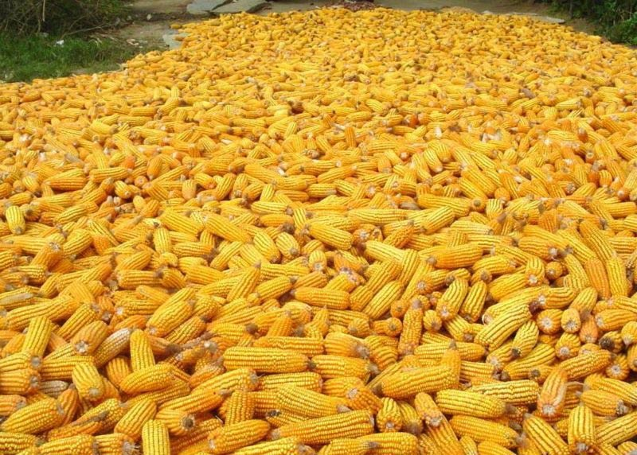HUMAN COMMUNITY SERVICES, INC is a non-profit (501c3) organization established in the South Florida area since 2002, with the primary objective of providing support to the needy, in several geographic areas of the Caribbean, South America, Africa and the United States, in as many domains as our sensibilities are called upon: food procurement, health care support services, education, job assistance among other services.

Our aim is to enlarge our reach and become involved in insuring the building and availability of infrastructures for the delivery of those services through multi-faceted projects, such as schools, hospitals, training facilities, technology hubs, water treatment facilities, food production farms and plants and the like.

***HCS PROJECT PROPOSAL***

***HCS AGRICULTURE***

***CORN /MAIS***

|  |
| --- |
|  |

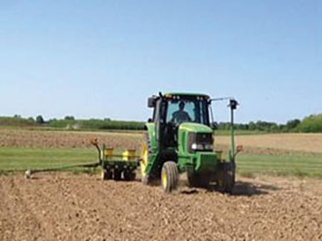

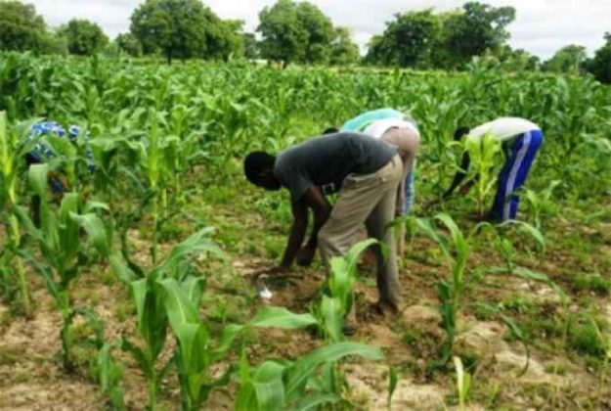

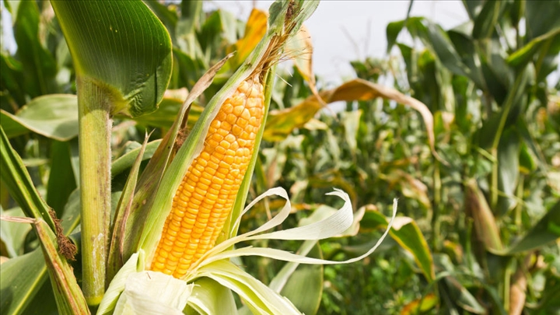

PREPARED BY

**Hon Stanley H Damas**

**President CEO**

**Patrick Arcelin**

**Project Director**

**Vladimir Warlick**

**Executive Director**

**HCS Haiti Agriculture**

**December 24, 2020**

**CONTENT SUMMARY**

**PAGE**

**Context- Understand the Agriculture Situation versus Poverty 3**

**Situation analysis  4**

**CORN… A Strategic Culture for Haitian Agriculture 4**

**Economic Growth and Agricultural Development 4**

**Why Corn… 5**

**Our Contribution to the Communities 7**

**Objectives and Strategies for Implementation 7**

**Strategy for Implementation 8**

**Relevance and Adequacy of the Project 9**

**Participation and Appropriation of the Project 9**

**Continuation of the Intervention 10**

**The Participation of the Community 10**

**Impact 10**

**Consistency 10**

**Benefits of Community Development 11 Agenda of goal 11**

**Objectives and methodology of the project evaluation 11 Project targets 12 General Framework and Strategies of the Project 13 Objectives of the Intervention 13 Expected operational lifetime of project activity 13 Active participation of the community (direct target groups) 13 Community inclusion 14 Project sustainability/ Approach/Strategy 14 Social Cohesion and Violence 14 Strategies 15 Objectives in the agricultural field: 15 Objectives in the field of employment: 16 Objectives in the field of the advancement of women: 16 Perceptions and Appraisal on the Project 16 Expected results 17 Potentialities, Socio-Economic Opportunities of Haiti 17 Arrangements and responsibilities**  **Estimated budget 18 CONCLUSION 20**

**Let’s Plant the seed to shape a new future for Haiti**

1. **Context**

**UNDERSTAND THE AGRICULTURE SITUATION VERSUS POVERTY**

The evolution of poverty in Haiti has been marked by major events that occurred in the course during the past 10 years. These events in Haiti led to the formation of a vicious circle, marked by recurring natural disasters striking the country at regular intervals (the four hurricanes in 2008) and increased vulnerability, mainly on the part of the poorest sectors of the population. Haiti until today remains extremely vulnerable to natural disasters with 96 percent of the population at risk.

Haiti’s agriculture plays a significant role in the Haitian economy, contributing to more than 25 percent of the country’s GDP. The sector employs about 57 percent of the active population, while providing 66 percent of employment in rural areas and 75 percent of employment to low-income rural households, thus representing the main source of income in rural areas. National agricultural production provides about 50 percent of food availability, which is complemented by commercial imports (45 percent) and food aid. The Departments struck by Hurricane Matthew had 85 percent of the national production of maize and 37 percent of the national fruit production under cultivation. These areas also accounted for about one third of the country’s stock of cattle, pigs, goats and poultry. Which impede both their rights and their capacity for recovery.

Being a free market economy with low labor costs and tariff-free access to the US for many of its exports, Haiti however needs to look at its capacity to produce locally. Since, two-fifths of all Haitians depend on the agricultural sector, mainly small-scale subsistence farming, which remains vulnerable to damage from frequent natural disasters, an effort needs to be made to change the farming method and raise its productive volume if Haiti needs to be competitive in the export market.

It is worth nothing that poverty, corruption, vulnerability to natural disasters, and low levels of education for much of the population represent some of the most serious impediments to Haiti’s economic growth.

Currently the poorest country in the Western Hemisphere, with close to 60% of the population living under the national poverty line, Haiti’s GDP growth rose to 5.5% in 2011 as the Haitian economy began recovering from the devastating January 2010 earthquake that destroyed much of its capital city, Port-au-Prince, and neighboring areas. However, growth slowed to below 2% in 2015 and 2016 as political uncertainty, drought conditions, decreasing foreign aid, and the depreciation of the national currency took a toll on investment and economic growth.

1. **Situation analysis**

Throughout its history, [Haiti](https://en.wikipedia.org/wiki/Haiti) has suffered cyclones, hurricanes, [tropical storms](https://en.wikipedia.org/wiki/Tropical_storm), torrential rains, floods and earthquakes; the hurricane season in Haiti lasts from June to the end of November. Haiti is a resilient society whose rural communities in particular have developed coping mechanisms in response to a long history of underdevelopment and political instability. The country’s religious, cultural, and artistic life is highly diverse and vibrant. Like other fragile states, however, Haiti is also beset by widespread poverty and inequality, economic decline and unemployment, poor governance, and violence.

**Human Community Services Inc.** has examine Haiti’s conflict Poverty-Agricultural trap from the perspective of the triangle factors that have been identified as its main components:

1. Demographic and socioeconomic factors at the individual and household levels;
2. The state’s institutional incapacity to provide used lands and manage social risks; and
3. The agendas and strategies of political actors in such fragile environments, to design a set of timing plan of Agricultural Development.
4. **CORN…**

**A Strategic Culture for Haitian Agriculture, a sustainable family’s community development project**

**Project Objective/Description:**

* To implement the creation of the Corn Processing Industry with TOMATOES as a strategy for rotation of culture.
* To create employment in the rural areas
* To create a Corn and tomato Farmer Coalition
* To promote economic growth
* To protect the environment
* To foster a strong community
* To improve the quality of life

1. **Economic Growth and Agricultural Development**

Haiti’s economic climate is challenging, ranking the country 181 of 190 on the World Bank Ease of Doing Business Index. Despite these challenges, Haiti has experienced some positive economic growth in recent years.  Additionally, agricultural potential for domestic and export markets is promising and an important driver of growth.

In the agricultural sector, HCS’s strategy focuses on sustainably increasing farmers’ incomes through the culture of CORN which we believe to be a Strategic Culture for Haitian Agriculture and Economic Development, with a modern approach measure that will increase productivity through the introduction of better inputs and improved technology with the implementation of the Corn Processing Industrialization that will help stabilize the agricultural markets through better access to domestic and international markets. The soil preparation being an important factor will require a **Rotation of Culture** with TOMATOES as a perfect substitute for the soil given its short harvesting time and its demand locally for tomato paste processing.

“Haiti's agricultural sector has a very high production potential, however, less than half of agricultural products supplied to the Haitian market - a population estimated at 10.9 million in 2015, according to the IHSI - are produced locally. Therefore, import substitution is an excellent opportunity to expand the supply of domestically produced products. The greatest asset of Haitian agriculture is that products are virtually free of any potentially harmful chemicals, in particular, of fertilizers, pesticides and herbicides”. USAID Sources.

1. **Why CORN…**

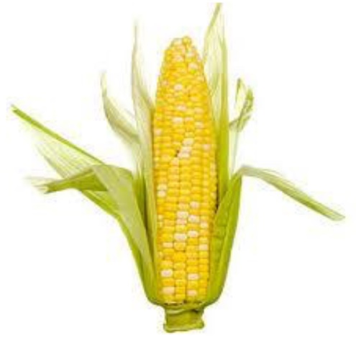

Corn spread across North America a few thousand years ago and today it is the third leading grain crop in the world. Over the centuries, the crop varieties underwent changes to get better yields, while farming methods were improved. As observed in the USA a lesson needs to be learned and puts in application for Agricultural Development and jobs creation purposes in Haiti.

Given the funding opportunity, HCS sees CORN as a new age of agriculture in Haiti and subsequently TOMATOES as a second plan during the **Rotation of Culture**. In the 1950s, [Henry A. Wallace](https://en.wikipedia.org/wiki/Henry_A._Wallace), former Vice President and former Secretary of Agriculture in the US, and an early developer of hybrid seeds, observed that "the Corn Belt had developed into the most productive agricultural civilization the world has ever seen". This trend has continued and now the corn production level in American farms is a significant 20% higher per acre than in the rest of the world. Similarly, at a smaller scale we could mirror these results as the growth of corn will spread to extensive production in the 10 departments of Haiti through a Corn Farmers Coalition.

**Production**

In acreage, corn shares the honors with [sorghum](https://en.wikipedia.org/wiki/Sorghum) as one of Haiti's two leading crops. Throughout the country it occupies a sizeable percentage of the cultivated land from about five percent in the sodden uplands north of [Camp-Perrin](https://haiti.fandom.com/wiki/Camp-Perrin) to 75 percent on the plateau of [Seguin](https://haiti.fandom.com/wiki/Fond_Jean-No%C3%ABl). Areas that regularly produce a surplus of corn for sale in the city markets are the [Grande-Anse](https://haiti.fandom.com/wiki/Grand%27Anse,_Haiti), the plateau of Seguin, and the vicinity of [Saltrou](https://haiti.fandom.com/wiki/Belle-Anse_Arrondissement).

Where two crops of corn are raised they are sown at the beginning of the spring rainy season (usually in March) and during the autumn rainy season (August or later). Customarily, the larger acreage is planted in the spring. At high altitudes, as at [Furcy](https://haiti.fandom.com/wiki/Kenscoff), [Seguin](https://haiti.fandom.com/wiki/Fond_Jean-No%C3%ABl), [Savane Zombi](https://haiti.fandom.com/wiki/Pot-de-Chambre), only one crop is planted in the spring.

Most of the corn raised in Haiti is of the old [West Indian flint](https://en.wikipedia.org/wiki/Flint_corn) stock in contrast with the [Dominican Republic](https://dr-local.fandom.com/wiki/Geography_of_the_Dominican_Republic), where recently introduced varieties of [dent corn](https://en.wikipedia.org/wiki/Dent_corn) are common. Haitian [agronomists](https://en.wikipedia.org/wiki/Agronomy) give resistance to weevils and [smut](https://en.wikipedia.org/wiki/Smut_(fungus)) as the reasons for retention of the flint. The natives distinguish varieties of flint corn on the basis of color and length of growing season. Yellow, red and white varieties, in order of decreasing abundance, of both long and short season corn are raised. Appropriately, the red corn is called *maïs du vin*, for its kernels have the hue or red wine. Red cobs, tassels, silk, stalks and husks are associated with the red flint, and often with the yellow flint as well.

In dry regions, as at Saltrou, two crops of three-month corn are grown in a year; in the moist lands below 1,000 meters (*3,280 feet*), one or two crops of five-month corn are grown; and in the cool highlands one crop of long season corn is raised. The three-month corn is preferred at Saltrou because of the short rainy seasons, whereas in areas of more abundant, dependable, and better distributed rainfall, long season corn is preferred for its heavier yields and the fact that the ears are high enough on the stalks so that dogs cannot reach them. It is estimated that **HCS Project** Haiti’s corn growth by the end of the year 2022 could be in the high of 18 tons per hectare or an average of 300,000 ton on a minimum of 16,000 hectare of land from farmers land owners and land own by CIG which will be dedicated exclusively to corn cultivation.

Through the participation of various economic groups, **HCS and its Partners** are working to create a revolutionary social business model for providing access to high level of employment while promoting the culture of corn to a much larger area throughout the country while also creating economic opportunities in some of the country’s most under-resourced communities. What a better way to start with: **Corn, a Strategic Culture for Haitian Agriculture**.

Noticing that the role of agriculture in the economy has declined, **HCS with its Partners** want to contribute in the relaunching of the **National Production** by investing in rural ventures and encouraging farmers to join the **Corn Framers Coalition** while keeping in mind the extreme deforestation, soil erosion, the ravages of natural disasters that has led to a critical environmental situation and land tenure.

1. **Our contribution to the communities**

The life condition of the farmers and their family needs to be taken in consideration as HCS and its partners implement the: **Corn, a Strategic Culture for Haitian Agriculture** with the construction of a completely furnished Community Center in each of the Department of the country which will be opened and accessible to all farmers, their family and other people in the area. Each Community Center will be self-supporting with a minimum average cost for services and will be run by a Village Committee. Each Community Center will include the following:

• Medical Clinic

• Telephone and internet

• Cultural center

• Office for village committee

• New technology

– Geothermal heat pump

– Solar panel

– Exhibits on village systems such as biogas, fuel cell.

– Sustainable Principle

• Establish community organizations for the benefit of all villagers, Passive solar design techniques will be used to efficiently provide indoor comfort throughout the year with little or no energy.

• Orient windows to the south for passive solar heat

• Fixed overhangs to shade windows in summer

• Good cross ventilation

• Thermal mass to hold heat and cool

• Flexible architecture

1. **Objectives and Strategies for Implementation**
2. **Objectives in the field of social action**:

- Promote community participation;

- Establish a reliable statistical system for the collection and processing of data on localities;

1. **Objectives in the field of education and manual skills**:

- - Increase by 50% the adult literacy rate;

- Identify manual skills in the field of construction, livestock and agriculture;

- Regular training for field workers.

As **HCS** is working for the betterment of the Farmers and their families, it has for general objective to modernize the Agriculture System, stimulate the National Production to begin with the production of the **Maize** ([/meɪz/](https://en.wikipedia.org/wiki/Help:IPA/English) [*MAYZ*](https://en.wikipedia.org/wiki/Help:Pronunciation_respelling_key); also known as **Corn** which is a [cereal grain](https://en.wikipedia.org/wiki/Cereal_grain) first domesticated by [indigenous peoples](https://en.wikipedia.org/wiki/Indigenous_peoples_of_the_Americas) in southern Mexico about 10,000 years ago.

This cereal has become an [essential food](https://en.wikipedia.org/wiki/Staple_food) in many parts of the world and especially in Haiti. In addition to being consumed directly by humans (often in the form of [masa](https://en.wikipedia.org/wiki/Masa)), maize is also used for [corn ethanol](https://en.wikipedia.org/wiki/Corn_ethanol), [animal feed](https://en.wikipedia.org/wiki/Animal_feed) and other [maize products](https://en.wikipedia.org/wiki/Category:Maize_products), such as [corn starch](https://en.wikipedia.org/wiki/Corn_starch), [corn syrup](https://en.wikipedia.org/wiki/Corn_syrup), animal feed, various corn-based human food uses (including grinding into [cornmeal](https://en.wikipedia.org/wiki/Cornmeal) or [masa](https://en.wikipedia.org/wiki/Masa), pressing into [corn oil](https://en.wikipedia.org/wiki/Corn_oil), and fermentation and distillation into alcoholic beverages like [bourbon whiskey](https://en.wikipedia.org/wiki/Bourbon_whiskey)), and as chemical feedstocks. Maize is also used in making [ethanol](https://en.wikipedia.org/wiki/Ethanol) and other [biofuels](https://en.wikipedia.org/wiki/Biofuel).

The potential in its production not only will create thousands of jobs, but also will create revenue with capital returns on the initial investment. Haiti as it prepares to enter the competitive market with a greater weight of maize produced each year, will slowly begin to go in the world market as one of the exporter of this cereal especially when the world production fails to meet a demand that grows even faster.

Animal feed: wheat's great rival

Animal feed is the main market for maize, whether harvested in grain or fodder. Grain corn is intended for poultry, sheep and pigs, corn fodder for cattle. The harvest can be consumed by the animals on the farm or be marketed.

The feed sector consumes 4 to 5 million tons of grain maize per year (out of 15.3 MT in 2009), of which an average of 3 million tons via feed manufacturers (FAB). The balance is consumed directly on the farm.

However, the sector has significant year-over-year incorporation fluctuations based on commodity prices: maize and wheat are in direct competition.

1. **Strategy for Implementation**

**a- The implementation of the project favors the interrelation of a number of actors, mainly:**

- Human Community Services Inc.

- Operation Hope

- The ClinicA Institute

- The Ministry of Agriculture

- The Ministry of Public Health

- The concerned town halls, ASEC, CASEC

- Community leaders for continued motivation with communities and their association

**b- The implementation of the project favors the acquisitions of the following:**

- Receiving and Processing Center including warehouse

- Operational Equipment

- Field equipment

- Combing Machine equipped with/Satnav Satellite system

- Planting Machines equipped with/Satnav Satellite system

- Sprayer Machines

- Tractors with equipped with/Satnav Satellite system

- Tractors with wagons

- Silos for incoming crops operated with propane or gasoil

- Trucks

1. **Relevance and Adequacy of the Project**

The project should be considered as relevant to the communities as well as to the authorities. It will respond initially to specific needs such as:

* Direct Jobs Creation.
* The creation of a Corn/Tomato Farmer Coalition
* The well-being of a population at high risk of epidemic scourges, due to the lack of services.
* The improvement of socio-economic of villagers.
* Boost the Haitian economy to the production of corn by the implementation of a Processing facility of the following products like:

1. Corn oil
2. [Cornmeal](https://en.wikipedia.org/wiki/Cornmeal) (Coarse, medium and fine)

Both byproducts above to be made available for the national and the international consumption.

1. **Participation and Appropriation of the Project**

HCS anticipates the awareness-raising strategy for this proposal should bear fruit in the population throughout the ten departments of the country especially in the Central Plateau and the South. Despite its bedridden state, the population will respond positively to requests for participation especially with its combined social approach by adopting behaviors indicating a good understanding of the issue at the community level

1. **Continuation of the Intervention**

The sustainability of the project will be analyzed through the opinions of the various parties concerned on the usefulness of the continuation of the intervention. The participation of the community with the creations of Village Committees will enhanced the improvement of the activities.

1. **The Participation of the Community**

Community participation in project activities will be measured through number of Member Farmer Coalitions, number of people hired and number of family involved in community activities.

The community’s contribution to the implementation of selection of community leaders, their awareness and motivation and its dynamism to the community and the construction of premises to house local supervision and coordination offices.

1. **Impact**

The goals of the **Corn.., A Strategic Culture of the Haitian Agriculture** project, is to:

1. Create opportunities for employment for **non-farmer owners** to include both men and women and especially women during the **Rotation of Culture** with tomatoes…
2. Create **Local Farmer coalitions** with a guarantee of purchase of their harvested corn.
3. Encourage and promote the awareness activities to improve their understanding of their housing environment, their water, hygiene and sanitation and production behaviors.
4. Ensure access to quality services within the locality by giving the members of this locality the capacity of autonomy for the purchase of goods and services through a practice of knowledge, responsibility for their well-being.

The communities will have to be able to make the observation of their situation of isolation and to reflect together on concrete solutions allowing them to make the best profits of their habitat by fully taking advantage of the socio-economic development of their community.

1. **Consistency**

The project proposes a multi-sectoral, integrated, complementary response that fits well with the activities of Jobs Creation, Social and Economic Development, Information, Communication, Training, Awareness and Management by the community.

1. **Benefits of Community Development**

Good community works, when locals use assets in new ways, mobilize existing skills, work cooperatively, put innovative ideas into action, and improve networks.

The planning of this project has for objective to work and to improve the social and economic life in the rural communities. It is important to build enthusiasm and confidence of the community people and to challenge overall community attitudes and perceptions while building relationships with inside and outside key individuals.

Implementing workshops to change existing skills, changing innovative ideas into action, teaching sustainable agriculture and climate change effects helps the residents to make good sustainable changes in their life and helps poorer people to rise from poverty.

1. **Agenda of goal**

* Promoting Community and Environmental sustainability
* Promoting social and economic equalities
* Promoting work ethics
* Promoting the dignity and worth of peoples
* Promoting community and environmental sustainability
* Promoting the importance of human relationships
* Achieve sustainable results, no poverty and no hunger. Achieve food security and improved nutrition and promotes sustainable agriculture within the targeted communities.
* Ensure inclusive and equitable quality participation of all farmers and promote lifelong training formation opportunities within the community while achieving gender equality and empower all women and girls and ensure them access to affordable reliable full time job opportunities.
* Promote employment and decent work opportunities.
* Protect land from degradation and halt biodiversity loss.
* Promote an inclusive society for sustainable development.

1. **Objectives and methodology of the project evaluation**

This evaluation of the results is intended to analyze the interventions carried out and the results obtained in relation to the objectives assigned to the project.

This analysis should make it possible to:

- Evaluate whether the conditions necessary for the sustainability of good practices developed in the context of sustainable development are established;

- Establish recommendations for maintaining or developing good practices.

The analysis may:

- Provide managers and state authorities with information on the acceptability and feasibility of the integration approach for sustainable development.

- Allow to verify the relevance of the intervention strategy and obtain a confirmation / denial.

- To adapt this one according to the recommendations of the evaluation for the interventions to come.

- Contribute to open avenues for reflection for sustainability.

- Bring an external perspective on the project and its realization. Understand what worked and the difficulties encountered (explanation of differences).

- Value the project's successes and capitalize them.

- Evaluate partnership mechanisms to highlight good practices and identify areas for improvement.

1. **Project targets**

Three targets were considered as part of the intervention:

1. Primary targets: Farmers Land Owners and Farmers non-Land Owners;
2. Secondary targets, formed by project participants at the operational level, town halls, Casec, Asec.
3. Tertiary targets, made up of community leaders, responsible for associative organizations, members of associations.
4. **General Framework and Strategies of the Project**

**Human Community Services Inc..**, sustainable Development Project in Haiti has as its ultimate goal to contribute to the improvement of the level and the quality of life of the Haitian families in the rural areas.

1. **Objectives of the Intervention**

The objectives of the intervention, which integrates the promotion of behavioral changes in communities for a better functioning of life, are mainly aimed at:

• Increase the recruitment of farmers in targeted localities, by strengthening the skills of community leader groups to use and take ownership of tools for diagnosing and managing sustainable development issues.

• Encourage the participation of women in different project area.

• Improve management capacity and service quality in the targeted localities;

• Increase the level of knowledge of the population about the complications of poverty and the changes about to take place.

1. **Sustainable Agriculture**

* The agricultural productivity has been optimized to produce a sustainable economy for the village.

1. **Location of Project Activity with a priority on the following Departments:**

* The Plateau Central Department
* The North Department
* The North Est Department
* The Artibonite Department

1. **Site Plan**

* Minimum new road construction
* Optimize land allocation for warehousing and community medical Clinics
* Efficient use of land space available for agriculture

1. **Expected operational lifetime of project activity.**

* Up to 25 years

1. **Active participation of the community (direct target groups)**

* Permanent

1. **Community inclusion**

Community engagement is crucial to assuring sustainable community development. Training will be given to the farming community to educate them on their options leading to an increase in their buying power and public awareness. The community should also be empowered to identify what they see as sustainability and these viewpoints should be included in the decision making process.

1. **Project sustainability/ Approach/Strategy**

Minimizes damage to the environment by:

* Strengthening the physical infrastructure of traditional agriculture.
* Creating new industries in the village.
* Creating a site plan for homes and shops that promotes economic and social interaction.
* Using advances in technology to integrate the infrastructure of the village (energy, water, transport, and communications) to the greatest extent possible

Minimizes damage to the environment by:

* Using the village's land and resources to meet the needs of the village to the greatest extent possible.
* Maximizing re-use of harvest waste for animal feeding and fertilizer to the greatest extent possible.

Local decision making in achieving community self-sufficiency is fundamental in the success and positive growth in every community. Community involvement is central to both the strategic planning and project planning. This documentation should explain and provide evidence of how the community was involved in determining problems faced by its members and in designing strategies for reducing or eliminating those problems.

1. **Social Cohesion and Violence**

Rural Haiti remains relatively peaceful and has a tradition of strong social cohesion. Especially in fragile states, the ability of communities and households to work and live together is essential to maintaining people’s livelihoods, security, and welfare. Social capital indicators that measure levels of trust and reciprocity suggest that robust cohesion on the community level has been crucial in preventing Haiti’s institutional-political crisis from deteriorating into broad social collapse or civil war. There are, however, sharp urban-rural differences: people in rural areas feel far safer in their daily lives than do urban residents.

1. **Strategies**

In order to achieve the objectives of the **Corn.., a Strategic Culture for Haitian Agriculture,** the project has adopted a strategy that privileges from the outset the participatory approach for the sharing of actions and skills at both departmental and community level:

- Land from the Farmers Coalitions will be made available to the program with guaranteed purchase of raw harvested grains.

- Land own by HCS and its partners will be prepped to that effect and available for corn production and rotation of culture with tomatoes.

- Land for the use of construction of the various infrastructures like: Medical Clinics, Community Centers, administrative buildings etc., will be made available to the project by the members of the community.

- Construction materials (rocks, sand, water), apart from iron and wood, will be provided by the community;

- HCS, in addition to providing the different construction plans of the model village will make sure to hire community members based on their skills identified for the construction of housing, infrastructure, and roads, for the irrigation pipelines.

- In order to remediate at the deforestation, each family employed by the company, will be responsible for planting 1.000 seedlings of fruit trees and ensuring their development and production; families to do this will be supervised by agents of agricultural development technology.

1. **Objectives in the agricultural field:**

- Promote sustainable and full time employment in the field;

- Promote family food security;

- Promote indirect animal production;

1. **Objectives in the field of employment:**

- Facilitate the integration of members in the various sectors of activity;

• In the corn field.

• In the processing plant (s) (With the first one installed in Plateau Central) for the purpose of extracting the byproducts like Corn Oil and Cornmeal (Coarse, medium and fine), to be sold to the national and market which profit will sustain the program for at least the next 25 years.

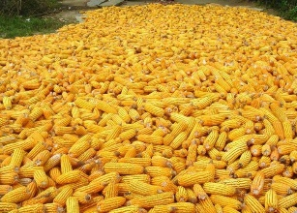

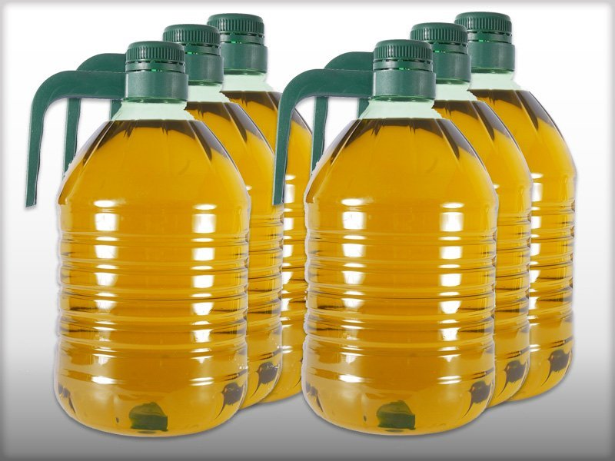

**HCS CORN OIL PRODUCTION**

1. **Objectives in the field of the advancement of women:**

- Facilitate access to income-generating activities for all women in the community

1. **Perceptions and Appraisal on the Project**

The evaluation aims to analyze people's perceptions, attitudes and adaptation to the project. The aim is to identify and predict the impact in terms of the employees' knowledge of the project, their commitment to the objectives of the intervention, their absorptive capacity and their assessments of the conditions for its implementation and its perpetuation.

The methodological approach, based on In-Depth Individual Interviews and Focused Discussion Groups, will provide qualitative information on the opinions of the various participants.

1. **Expected results**

Result 1: The project is disseminated within the communities.

Result 2: Communities participate in project development.

Result 3: Hundreds of women and men are hired in the rural communities.

Result 4: The sales of the byproducts such as corn oil and cornmeal for the national consumption will keep the program running for at least 25 years.

1. **Potentialities, Socio-Economic Opportunities of Haiti**

**Arrangements and responsibilities**.

The duration of the project will be 25 years. It will be executed by **Human Community Services Inc.**, in close collaboration with other sector-based Ministries. Technical and operational support leading to the delivery of the proposed outputs will be provided by a team the same and thematic specialists, consultants and administrative staff, contracted by Human Community Services Inc., operating at central and regional levels.

This project aims not only to counter tropical threats, but also to participate in the identification of potentialities and their use in a comprehensive program of integral development. These opportunities exist in terms of agricultural land and opportunities for the development of trade with guidance for the socio-economic integration of community members.

This plan is therefore essential as a need to intervene in order to defeat the manifestations of an unprecedented humanitarian and social crisis.

The implementation of the plan, will initially, to train the members in an orderly and controlled way to give them confidence in themselves and their local lands thus dissipating any root of frustration by dissatisfaction of the primary needs that may lead to recrudescence delinquency.

In a second step, the socio-economic integration phase through community apprenticeship in manual trades, access to health care will contribute significantly to reducing unemployment, curbing land abandonment and rural exodus and to make a shift towards the sustainable development of the different communities.

The department of Plateau Central, Nord Est, Nord and the Artibonite will serve as a model for the erection of villages where the integration of the various services will allow the members of the localities to participate actively in the sustainable employment, the development of their communities while having the mental and financial capacities to enjoy the goods and services generated within of their commune.

1. **Estimated budget Project Management and Monitoring**

Following the HCS internal budget tools, some tables of data have been highlighted, just to ensure that all necessary budget lines and requirements are discussed and taken into account.

|  |  |
| --- | --- |
| **Country Data Entry** | |
| Daily wage for agricultural labor | USD/day |
| Machinery rental rate (average rate with fuel included) | USD/hour |
| Annual farm land rental (national average) | USD/ha |
| Capital interest rate (short term) | % |
| Selection and unit prices of fertilizers | USD/t |
| Water tariff for agricultural uses | USD/m3 |
| Diesel price for agricultural uses | USD/l |
| Petrol price for agricultural uses | USD/l |
| Electricity price for agricultural uses | USD/kWh |
| **Crop data entry** | |
| Current farm-gate price for each selected crops | USD/t |
| Price of seed if applicable for selected annual crop | USD/kg |
| Seedlings/cuttings (total cost per hectare) if applicable for selected annual crop | USD/ha |
| Cost for establishing plantation for permanent crops | USD/ha |
| **Irrigation data entry** | |
| Crop water deficit | mm |
| Irrigation system, water source, pumping system Average depth of the groundwater | m |
| Irrigation system investment (capital cost) | USD |
| Average lifespan of the irrigation system selected | years |
| Hectares covered by the investment of irrigation system | ha |
| **Inputs** | |
| Seed | Kg/ha |
| Seedlings/cuttings (total cost per hectare) | USD/ha |
| **Fertilizer nutrients:** | |
| - Nitrogen | Kg/ha |
| - Phosphorus | Kg/ha |
| - Potassium | Kg/ha |
| Other agrochemicals | % |
| **Labour** | |
| **Land preparation** | |
| - Manual | man-days/ha |
| - Machinery | hours/ha |
| **Planting operation** | |
| - Manual | man-days/ha |
| - Machinery | hours/ha |
| **Post-planting operations** | |
| - Manual | man-days/ha |
| - Machinery | hours/ha |
| **Harvesting** | |
| - Manual | man-days/ha |
| - Machinery | hours/ha |
| **Miscellaneous** | |
| - Other | % |
| **Fixed Costs** | |
| Land acquisition (rental), plant and equipment | USD |
| Depreciation of plantation | USD |
| Investment | USD |
| **Indirect Costs** | |
| Medical Assistance package for employees/farmers | USD |
| Unforeseen cost, inflation, administration cost. | USD |

|  |
| --- |
| Inputs______________________15% **USD 3,000,000**  Labour_____________________30% **USD 6,000,000**  Fixed Costs_________________45% **USD 9,000,000**  Indirect Costs_______________ _10% **USD 2,000,000**  Total Estimated Budget: 100 % **USD 20,000,000** |

**CONCLUSION**

Haiti’s social resilience and social capital, its vibrant cultural life and improvements in social indicators are keystones to draw upon in breaking the conflict-poverty trap. With the culture of corn that has become a [staple food](https://en.wikipedia.org/wiki/Staple_food) in many parts of the world, with its [total production surpassing](https://en.wikipedia.org/wiki/List_of_most_valuable_crops_and_livestock_products) that of [wheat](https://en.wikipedia.org/wiki/Wheat) or [rice](https://en.wikipedia.org/wiki/Rice), Haiti is sure to be making the very first step in a competitive worldwide market.

With the capacity to transform the corn in at least three of the basic by products, Haiti will be soon join its counterparts in the competitive national and international market. As such, the Haitians in the rural communities deep and widespread poverty results from a long history of failure to establish even basic enabling conditions for broad-based social and economic development, will raise high to the apogee of the betterment of a their society longing for economic ease and access to the basic necessities while proudly work and making a standard living condition for themselves and their families.

**CORN.., A Strategic Culture for Haitian Agriculture, a sustainable family’s community development project,** addresses the issue in a very smart and innovative way.

* Ecology
* Economy
* Product Transformation